1. **Gajula, Vineeth**
2. Team D – Phoenix
3. Client: Dr. Michael Oudshoorn (oudshoorn@nwmissouri.edu)
4. Project: Slack/Hipchat collaboration tool
5. Team Role: Communications and documentation management
6. Iteration plan:

I have been assigned the role of Communications and documentation management for this project. I am responsible for tracking the changes in documentation and manage the communications for the project. I think 10% of work is completed by designing use cases and writing project management plan. I think that the requirements in which am involved are a bit behind the schedule for this week. To get back on track I think I should document the test case for the shared calendar which am working on.

**Accomplishments made last week:**

I have designed use case diagram for the shared calendar which comes under requirement 1 for the project. The use case diagram tells about the various functionality a user can perform while interacting with the system like creating, editing, deleting an event, or sending invitations for the event etc. For now, I have designed it based on what I worked on writing the project management plan describing what the project overview is, what are the project deliverables, what type of organizational structure is implemented, few project responsibilities, budget allocation and project schedule. Had a meeting with client and talked about the functional requirements for the project. Below are the notes taken from client discussion.

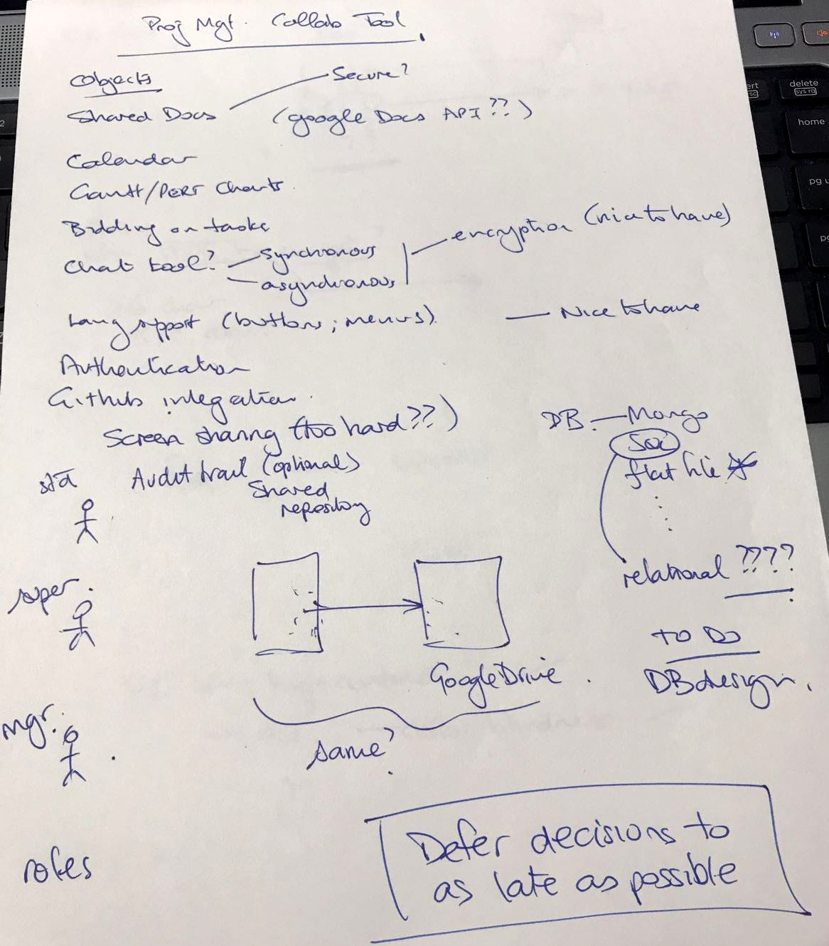

Fig 1. Client Notes

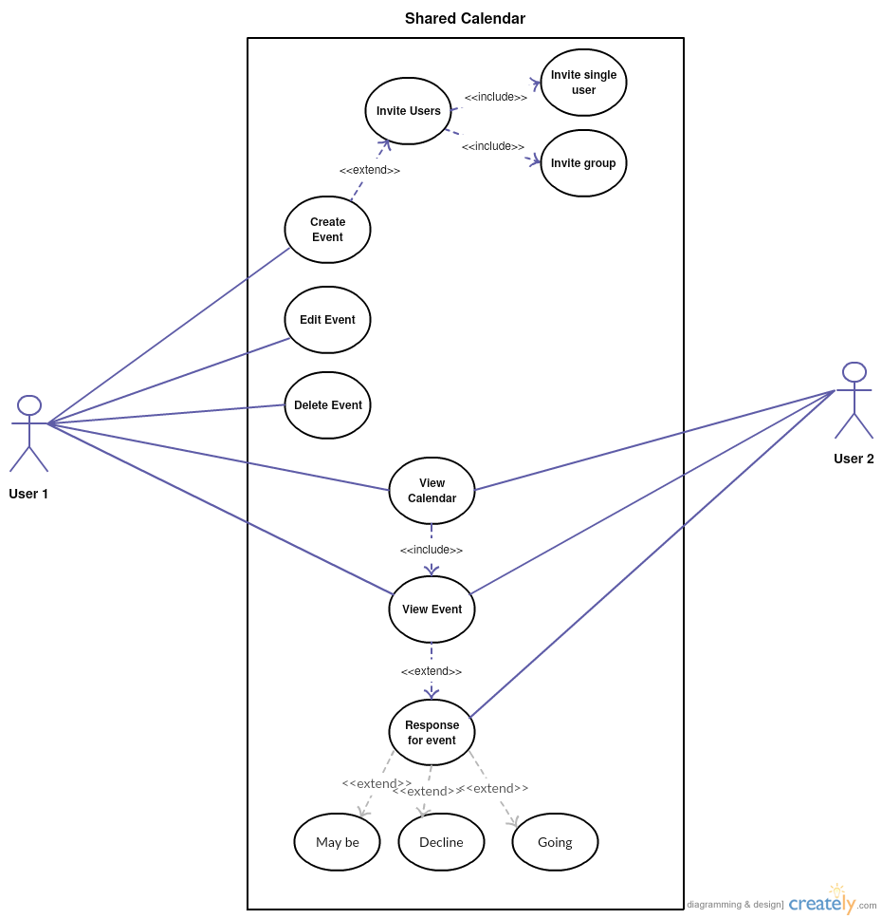

Fig 2. Use case diagram

I spent around 39 hours outside class towards the project.

**Tasks to complete this week:**

* Finish the requirement 1 (**R1**) which is in the functional requirements section.
* Draw Gantt Charts for the project which shows the amount of work distributed and work done.
* Write the Effort distribution for the project.
* Write the cost estimation and time estimation efforts for the project.
* Manage the documentation for this week’s group report and make sure it gets pushed to the GitHub repository.
* I will dedicate 39 hours this week outside the class to contribute towards the progress of the project.

1. **a copy of a complete post from one week ago**

**Gajula, Vineeth**

Team D – Phoenix

Client: Dr. Michael Oudshoorn (oudshoorn@nwmissouri.edu)

Project: Slack/Hipchat collaboration tool

Team Role: Communications and documentation management

**Iteration plan:**

I have been assigned the role of Communications and documentation management for this project. I am responsible for tracking the changes in documentation and manage the communications for the project. I think 5% of work is completed by having a client meeting and gathering some crucial requirements to get started with the project. I think that the requirements in which am involved are on track for this week. Since I manage documentation, I think tracking all the changes and maintaining them are critical to the project. I was involved in deciding the right tools and technologies used to build the project. I also think that these are very crucial for the project as they form the foundation for building the project in right direction.

**Accomplishments made last week:**

Researched about slack, hipchat and other collaboration tools. Figured that, the experience I had in a web apps course in creating a real-time web-based chatting app using Socket.io – JavaScript library, could somehow help in this GDP project if we build a web application. Created a hipchat account and browsed a variety of functionalities it offers like live chat rooms, sharing files, switching between teams etc. to get an idea about how collaboration tool works. Came to know that these collaborative tools are available as desktop apps as well as mobile apps across iOS, Android, and Windows. I have created a GitHub repository for the team to store all the project documents. I spent around 12 hours outside class towards the project.

**Tasks to complete this week:**

* Have a few more client meetings and get to know more about project description and requirements about the project.
* Meet with the team and decide on the platform to build the project.
* Suggest tools and technologies for this project.
* Manage the documentation for this week’s group report and make sure it gets pushed to the GitHub repository.
* I will dedicate 15 hours this week outside the class to contribute towards the progress of the project.

     What is the riskiest component under development?

I think to decide on what tools and technologies we should use for building the project are the riskiest components under development.

     What active efforts are most critical for client acceptance or GDP completion?

Understanding client requirements and working as a team to produce a finished quality product is very crucial as it leads to the completion of GDP.